BOARD RESOLUTION
RESOLUTION NO. BR/2026/09/001
RESOLUTION NUMBER | DATE
BR/2026/09/001 | 06 September 2026

BOARD RESOLUTION FOR THE APPOINTMENT OF REGISTERED REPRESENTATIVES TO THE SOUTH AFRICAN REVENUE SERVICE (SARS)
The Board of Directors of the African Solidarity Civic Organisation (ASCO NPC), duly constituted and acting in accordance with the Memorandum of Incorporation and all applicable laws of the Republic of South Africa, hereby unanimously resolves as follows:
APPOINTMENT OF REGISTERED REPRESENTATIVE
The Board hereby appoints Mr. Thapelo Nelson Maqalika, Director: Head of ICT and Communications, to act as a Registered Representative of ASCO NPC with the South African Revenue Service (SARS).

Mr. Maqalika is authorised to:
- Register and maintain the organisation’s SARS profile;
- Submit and manage all tax-related registrations, returns, and correspondence;
- Receive and respond to communications from SARS;
- Access and update SARS eFiling records; and
- Perform all lawful acts necessary for the administration of ASCO NPC’s tax affairs.

AUTHORITY OF THE EXECUTIVE DIRECTOR
The Board further resolves that Mr. Bhekisisa Shandu, Executive Director, shall possess the same level of authority and access to the South African Revenue Service (SARS) as Mr. Thapelo Nelson Maqalika.

Mr. Bhekisisa Shandu is authorised to:
- Access the SARS eFiling profile of ASCO NPC;
- Act as a Registered Representative where permitted by SARS;
- Submit documentation and correspondence;
- Communicate directly with SARS officials; and
- Perform all functions necessary for the effective administration of the organisation’s tax affairs.

EFFECTIVE DATE
This resolution shall take effect immediately upon its adoption by the Board of Directors and shall remain in force until amended or revoked by a subsequent Board Resolution.

CERTIFICATION
We, the undersigned, certify that this resolution was duly adopted by the Board of Directors of the African Solidarity Civic Organisation (ASCO NPC) and remains in full force and effect.

SIGNED ON BEHALF OF THE BOARD OF DIRECTORS

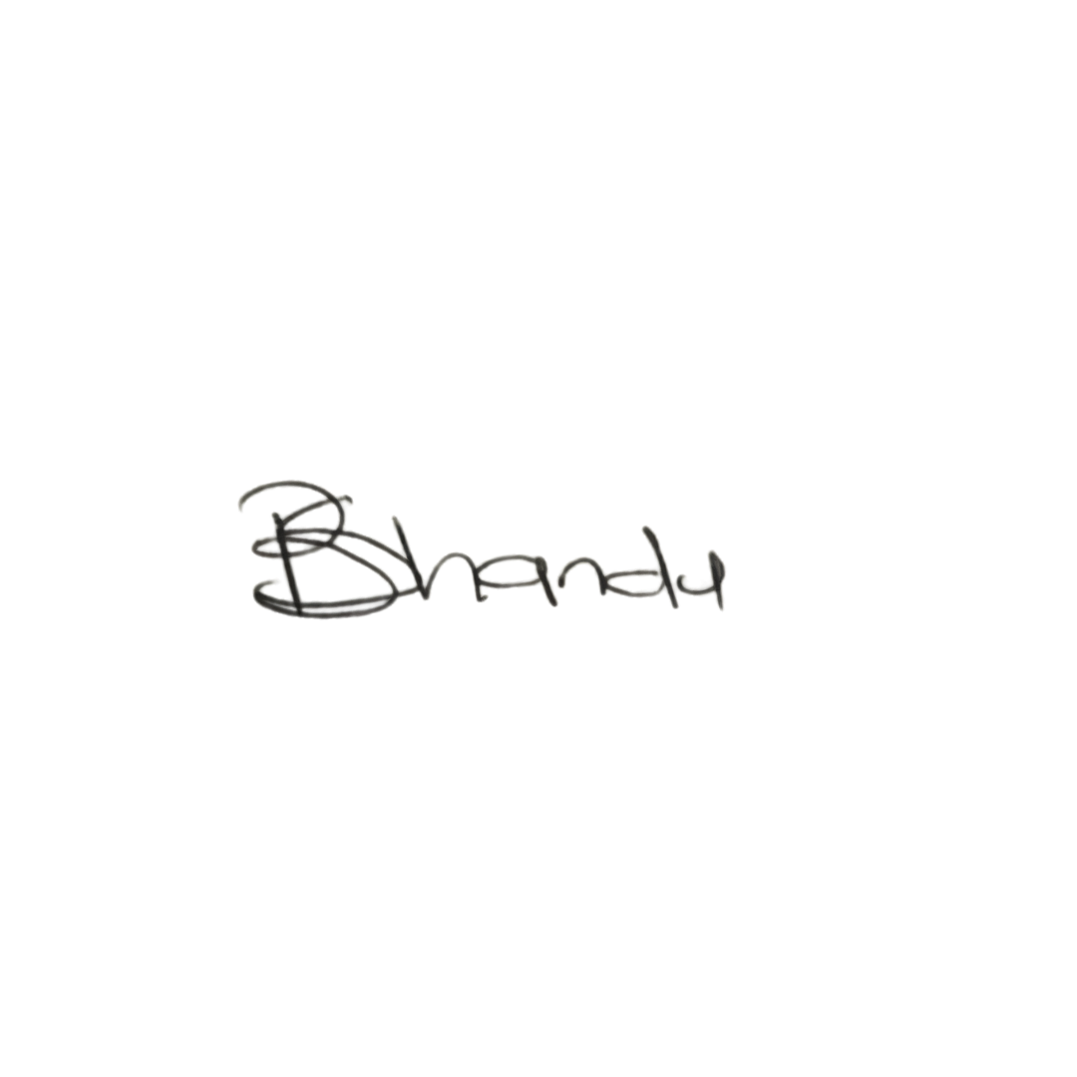  CHAIR LADY  Ms. Busisiwe Makhosi Shandu  Signature:  ____________________________  Date: 6 September 2026  ____________________________ | 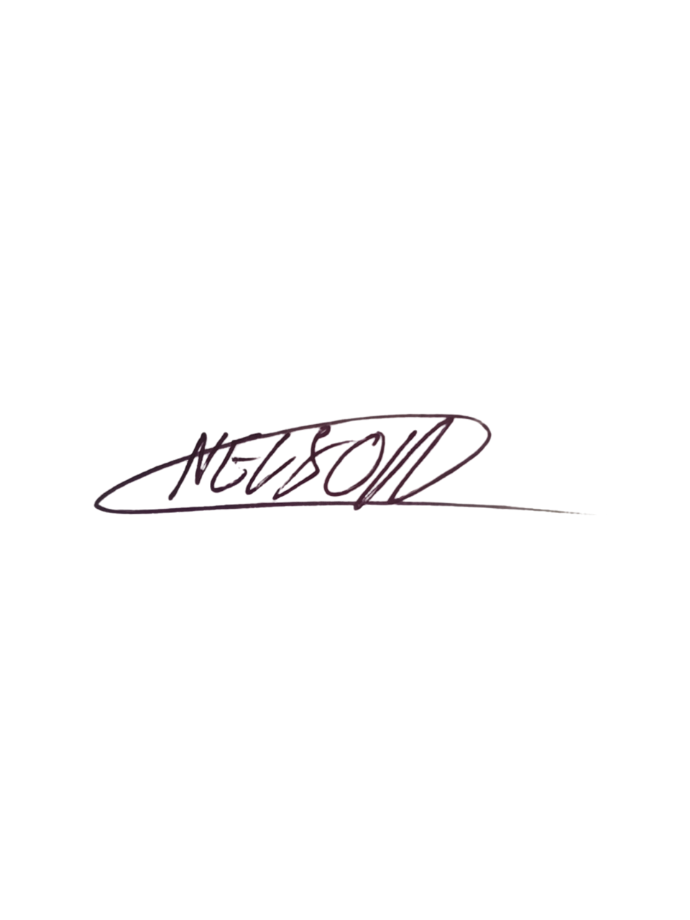  DIRECTOR: HEAD OF ICT AND COMMUNICATIONS  Mr. Thapelo Nelson Maqalika  Signature:  ____________________________  Date: 6 September 2026  ____________________________
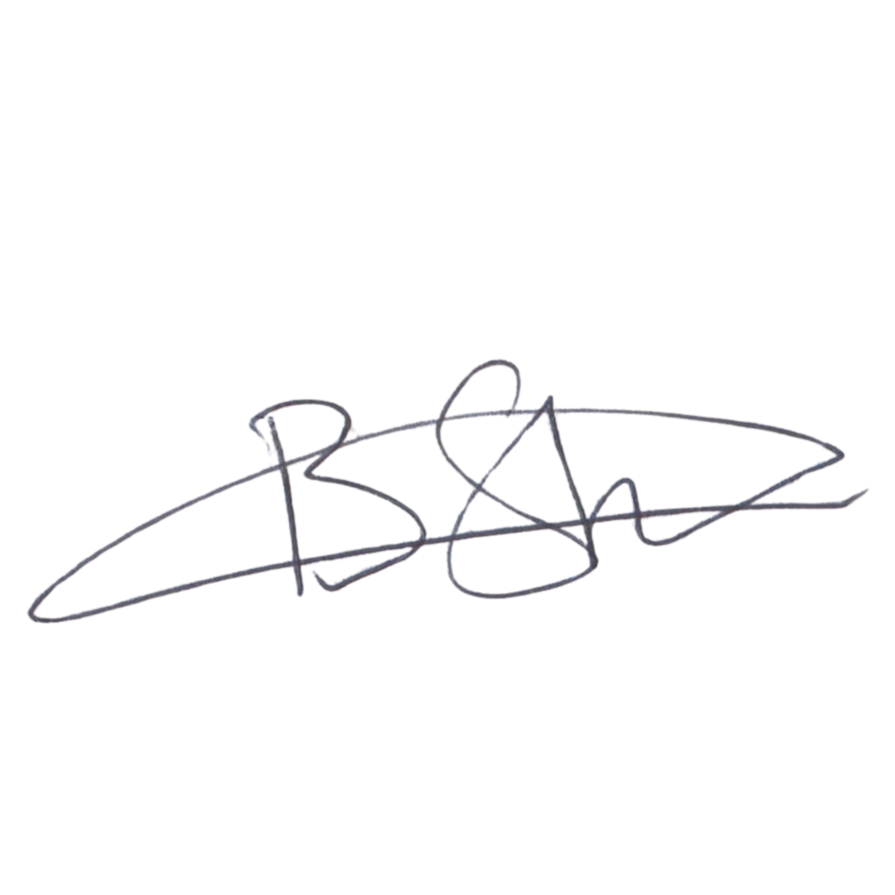  EXECUTIVE DIRECTOR  Mr. Bhekisisa Shandu  Signature:  ____________________________  Date: 6 September 2026  ____________________________ | 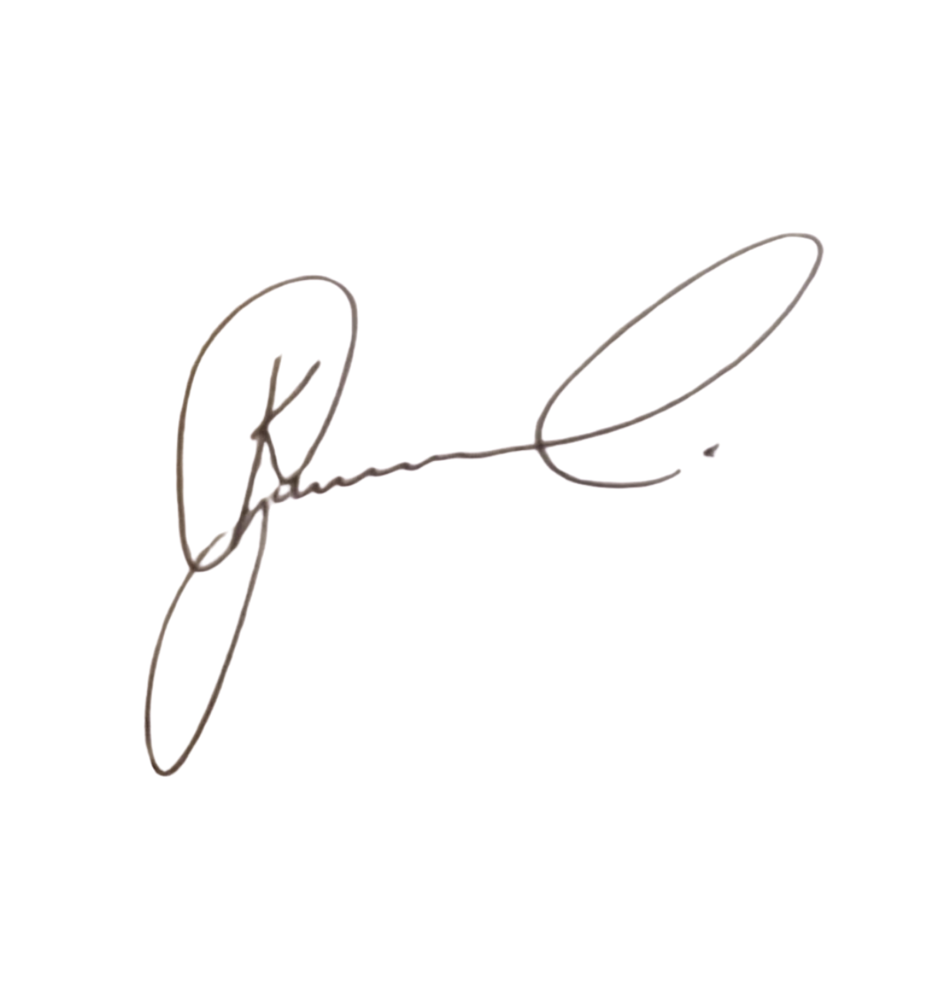  DIRECTOR: PEOPLE AND CULTURE / CHAIRPERSON: FINANCE AND PROCUREMENT COMMITTEE  Mr. Khulekani Gumede  Signature:  ____________________________  Date: 6 September 2026  ____________________________
ASCO NPC • Reg. No. 2026/521895/08 • Tax Ref. 9322812265

